**Practical-17☺**

The National Sports Federation has developed an app to track a runner’s distance during a marathon. The runner starts from 0 km and covers 0.5 km every minute. The app needs to display the distance covered at each minute until the runner completes a total distance of 10 km. Write a program to simulate the distance tracking. Note: Use an infinite while loop with a break statement to stop tracking after the runner has completed the marathon. Expected sample outcome: Minute 1: Distance covered = 0.5 km Minute 2: Distance covered = 1.0 km ... Minute 20: Distance covered = 10.0 km Marathon complete!

***Code:***

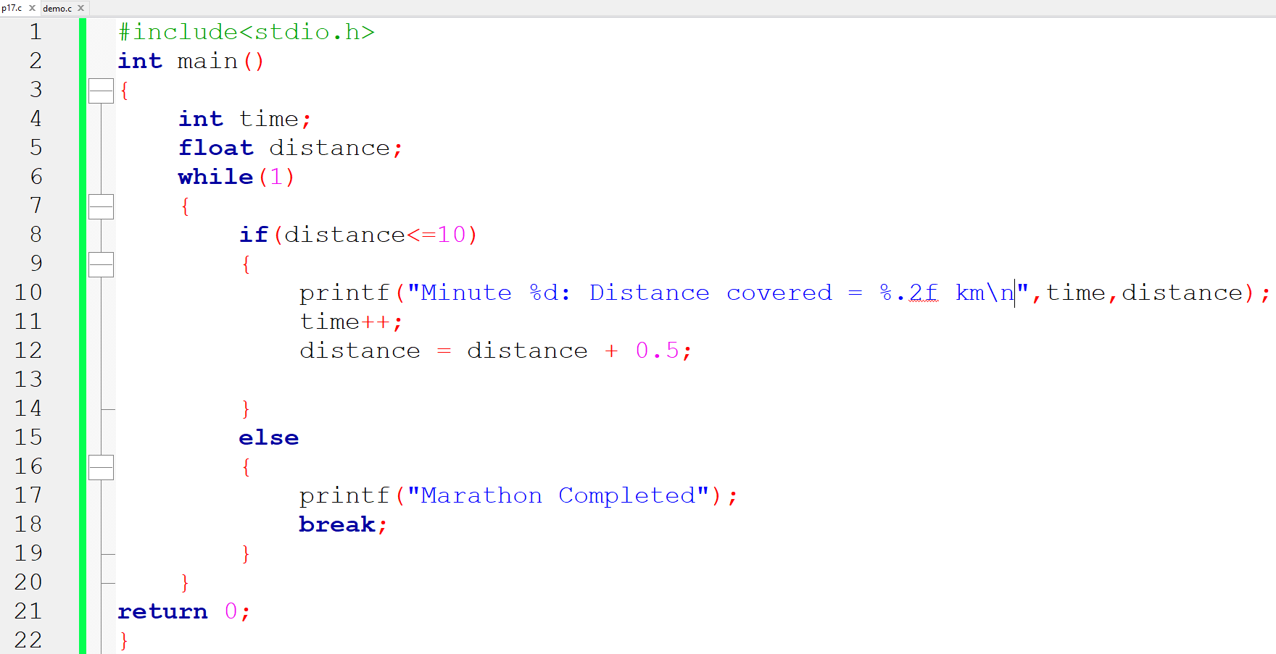

**Output:-**

